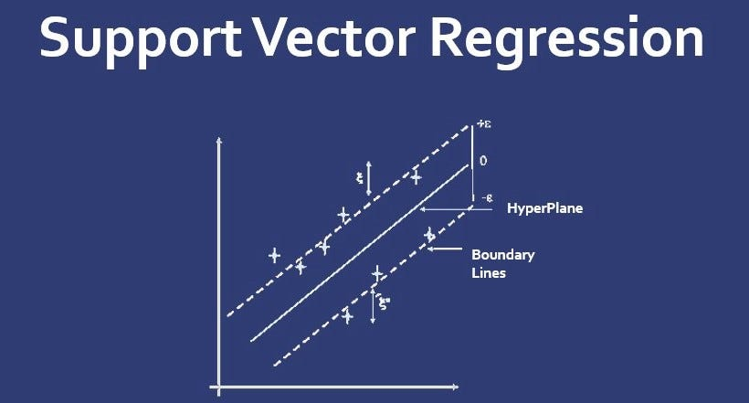
SVR (support vector regression) is actually a part of SVM (support vector machine),Support Vector Machine is a supervised machine learning algorithm and it is useful in solving both classification and regression problems.
The goal of the SVM is to train a model that assigns new unseen objects into a particular category. It achieves this by creating a linear partition of the feature space into two categories. Based on the features in the new unseen objects, it places an object above or below the separation plane, leading to a categorisation.

Linear Support Vector Regression
SVR uses the principle of SVM and create regression model. In SVR, instead of a line or a hyperplane there is a Ɛ-tube and we have regression line in middle of Ɛ-tube.
This tube has a width of Epsilon and the width as Bush measured vertically is along the axis, not perpendicular to the tube but vertically and this tube itself is called the Ɛ-insensitive that means that any point in the dataset that fall inside the tube we’ll be disregarding their error.
The width of the epsilon-insensitive tube in Support Vector Regression (SVR) is determined by the parameter ε (epsilon). This parameter defines a region around the regression line where errors (deviations) are not penalized as long as they fall within this region. The width of the epsilon tube is thus twice the value of ε, extending on both sides of the regression line.
Mathematically, the width of the epsilon tube can be represented as:
Width of Epsilon Tube = 2 * ε
In SVR, data points that fall within this tube are considered correctly predicted and are not penalized. Data points that fall outside this tube are subject to penalties based on their deviation from the tube, as quantified by the slack variables.
Choosing an appropriate value for ε is important, as it affects the trade-off between model complexity and flexibility. A larger value of ε allows for larger deviations from the regression line, resulting in a wider tube and potentially a simpler model. Conversely, a smaller value of ε leads to a narrower tube, enforcing a stricter fit to the data.
The choice of ε should be based on the characteristics of the data and the desired balance between model complexity and accuracy. It's often determined through techniques like cross-validation, where different values of ε are tried and evaluated on validation data to find the one that generalizes well to unseen data.
In Support Vector Regression (SVR), slack variables are introduced to relax the strict margin and epsilon-tube constraints in the optimization problem. Slack variables allow for some degree of tolerance in fitting the data points within the epsilon-insensitive tube and on the correct side of the margin.

In the context of SVR, there are two types of slack variables:

Epsilon-Slack Variables (ξ and ξ'):
ξ: For data points above the regression line.
ξ': For data points below the regression line.
These slack variables represent the deviation of individual data points from the margin or the epsilon-insensitive tube. They quantify how much a data point is allowed to be on the wrong side of the margin or outside the tube while still being penalized.
The introduction of slack variables modifies the optimization problem as follows:
Objective Function:
0.5 * ||w||^2 + C * Σ(ξ + ξ')
Constraints:
yi - f(xi) <= ε + ξ
f(xi) - yi <= ε + ξ'
ξ, ξ' >= 0
Incorporating slack variables softens the constraints, allowing some data points to lie outside the strict margin or the epsilon-insensitive tube if they are within the allowed margin of error (ξ or ξ'). The parameter C controls the trade-off between maximizing the margin and minimizing the deviations, similar to its role in the C-SVM classification.
In other words, the introduction of slack variables makes the SVR model more flexible and capable of handling noisy or imperfect data points while still maintaining the balance between fitting the data and preventing overfitting.
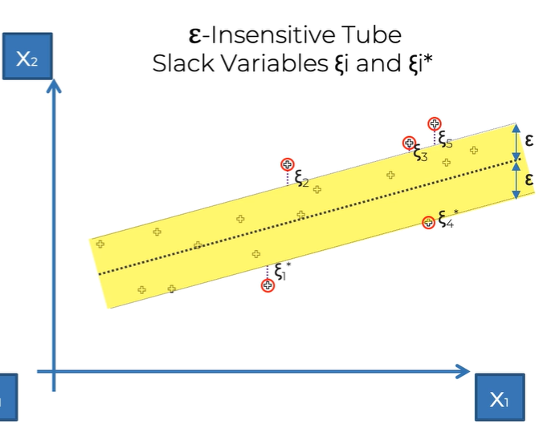
So basically, this Ɛ-tube think of it as a margin of error that means we are allowing our model to have those point and not care about any error inside it. So, any discrepancy between or any like distance between the point and regression line or the hyper plane, we don’t care about the area because it falls with the Ɛ-insensitive tube.
For the points that lies outside the Ɛ-insensitive tube we will consider them and take care of them by measuring the distance between the point and the tube itself and these value/points are called the Slack variables.
The formula for measuring the distance/area is:
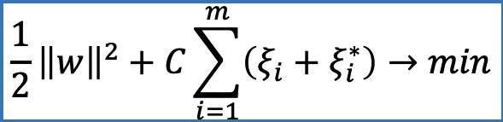

Support vector
The points that lie outside the Ɛ-insensitive tube are dictating that what the tube will look like and how the tube will be positioned. So, these point outside the tube, they are known as Support Vectors and helps in formation of the Ɛ-insensitive tube.
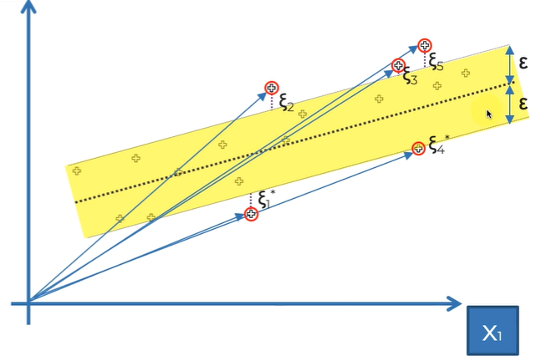
This method is called Support Vector Regression because effectively all of the points can be represented as a vector in the two-dimensional space or a multi-dimensional if we have more feature in the dataset.

Non-Linear Support Vector Regression
In Non-Linear Support Vector Regression, the data is not separable by using straight line or regression lines. So, to solve this problem we are going to higher the dimensional space and make the data linearly separable.
Here we increase the dimensional space of the data from 2D space to 3D space and now it is clearly visible for us to and now we can easily separate the data.

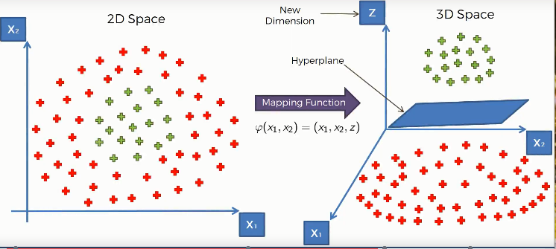
Here we used a mapping function (a function that maps the lower dimensional data points in a higher dimensional space), that elevates our data points into a higher dimensional space where they become linearly separable. And we find a hyperplane that classifies the data points into two distinctive classes.
In SVR we increase the dimensional space of data by using Kernel Trick. There are different types of Kernal. Some most used kernels are- the Gaussian RBF Kernel, Polynomial Kernel, Sigmoid Kernel etc.
Here we choose the Gaussian RBF Kern

Kernel
We can assume Kernel as a similarity function which implicitly maps the data to an infinite dimension plane and then find the support vectors in that plane and map the vectors back to the original dimension.
Kernel parameters select the type of hyperplane used to separate the data. Using ‘linear’ will use a linear hyperplane (a line in the case of 2D data). ‘rbf’ and ‘poly’ uses a non-linear hyper-plane.

